

# Vaccination Booking System

**DOCUMENTATION BY:**

Asfia



# CERTIFICATE OF COMPLETION

This is to certify that **ABDUL SAMAD, ASFIA, ABDULLAH ASIF, ANUSHAY KHAN,** and **SYED AUN AHMED** have successfully completed their DISM Semester E- Project.

Submitted to: **Aptech Computer Education** On

**August 1st, 2025**



# ACKNOWLEDGEMENT

First of all, we would like to thank Almighty Allah for giving us strength and ability to complete this project.

And then, we would like to express my special thanks of gratitude to our teacher **Sir Murtaza** who guided us on the project *VACCINATION BOOKING SYSTEM* which also helped us in doing a lot of new learning and we came to know about so many new things we are really thankful to him.

We are highly thankful to **Sir Murtaza** for his guidance and constant supervision as well as for providing necessary information regarding the project & also for his support in completing the project.

Lastly, we would also like to thank our parents and friends who helped us a lot in finalizing this project within the limited time frame. We also express our sincere gratitude to E-Project team from Aptech Head Office, for their valuable guidance and support for the completion of this project. We earnestly hope that this project will provide all the necessary information required by the user to fulfill his/her inspiration. However, suggestion and Feedbacks for improvements will be thankfully welcomed & acknowledged*.*



# PROBLEM DEFINITION

In the current healthcare system, vaccinations for infants and children are often administered manually through schools or health camps. This traditional method can lead to missed vaccinations due to lack of awareness, or scheduling conflicts. As a result, children are left vulnerable to preventable diseases like polio, which can lead to severe health consequences or even death.

To address these issues, a digital vaccination management system is required that enables parents, hospitals, and administrators to coordinate effectively, ensuring timely and complete vaccination coverage.

# REQUIREMENT SPECIFICATION



**Admin Module:**

* + View and manage all child details.
  + Schedule and manage vaccination dates and times.
  + Generate vaccination reports (child-wise and date-wise).
  + Maintain a list of vaccines with availability status.
  + Handle parent requests — approve or reject them.
  + Add, update, or delete hospital records.
  + View the list of all hospitals.
  + Monitor booking and scheduling details.

**Parent Module:**

* + Register and log in securely.
  + Add and manage child information.
  + View upcoming vaccination dates.
  + Book appointment with hospitals.
  + Send requests to hospital for vaccination services.
  + View history/reports of vaccination taken.
  + Update personal profile details.

**Hospital Module:**



* + Register and log in securely.
  + Update the status and availability of vaccines.
  + View and respond to vaccination booking requests.

# ARCHITECTURE

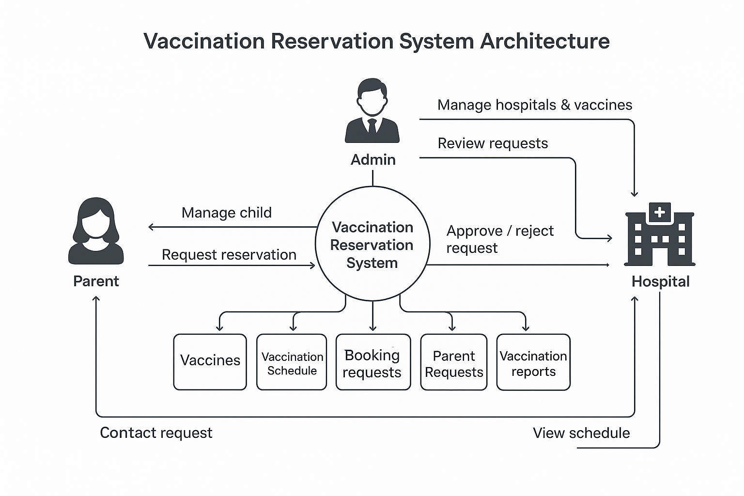



# FLOWCHART



# DATA FLOW DIAGRAM



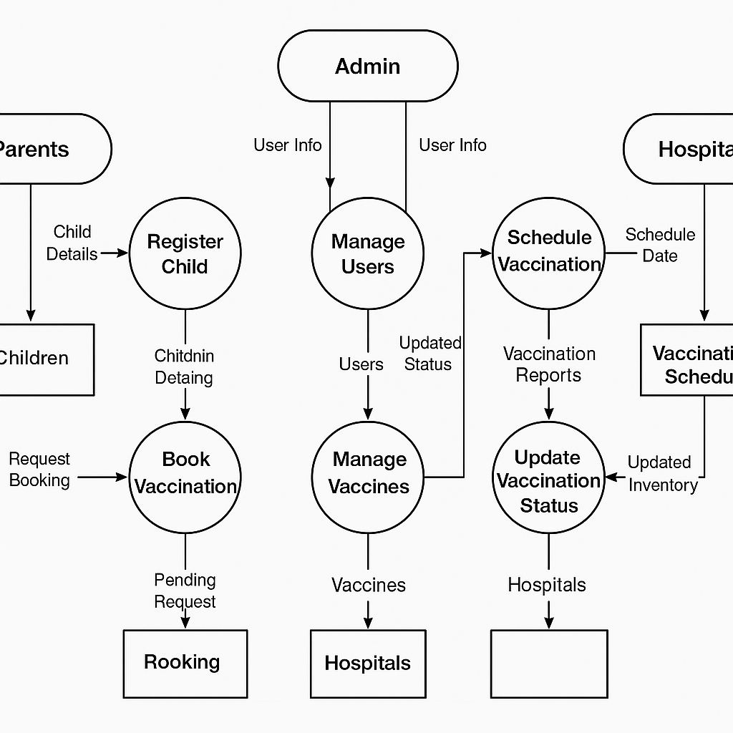

# ENTITY RELATIONSHIP DIAGRAM



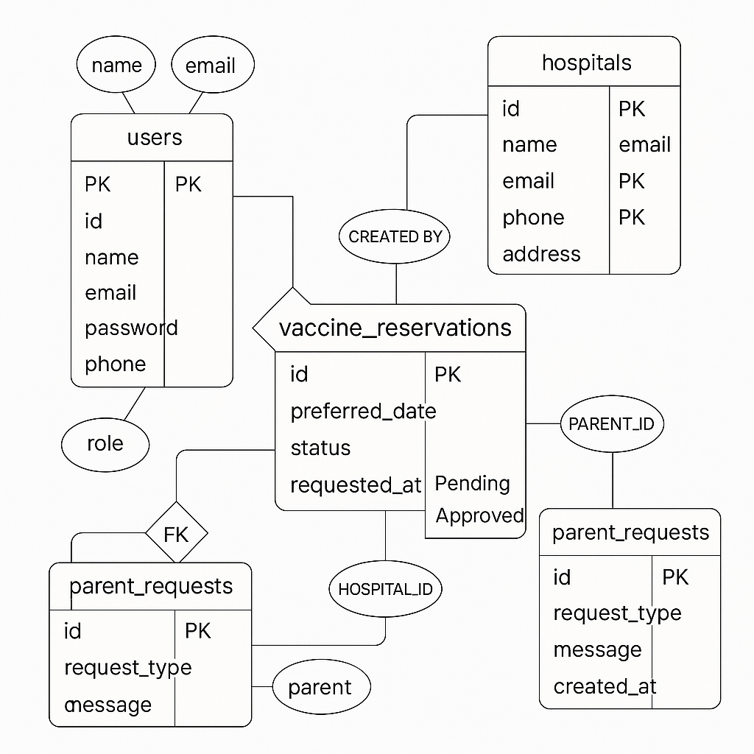

# DATABASE DESIGN



**USERS TABLE:**

|  |  |  |  |
| --- | --- | --- | --- |
| **COLUMN** | **DATA TYPE** | **KEY** | **DESCRIPTION** |
| id | INT(11) | PK, AUTO_INCREMENT | Unique user ID |
| name | VARCHAR(100) | NOT NULL | Full name |
| email | VARCHAR(100) | NOT NULL, UNIQUE | Email address |
| password | VARCHAR(225) | NOT NULL | Hashed password |
| role | ENUM (‘admin’ , ’parent’ , ’hospital’) | NOT NULL | User role |
| phone | VARCHAR(20) | NULL | Phone number |
| address | TEXT | NULL | Address |
| created_at | DATETIME | DEFAULT CURRENT_TIMESTAMP | Account creation date |

Represents all users of the system including admins, parents and hospitals.

**Children:**

Represents children registered by parents.

|  |  |  |  |
| --- | --- | --- | --- |
| **COLUMN** | **DATA TYPE** | **KEY** | **DESCRIPTION** |
| Id | INT(11) | PK, AUTO_INCREMENT | Unique child ID |
| Parent_id | INT(11) | FK → users(id) | Refrence to parent |
| Name | VARCHAR(100) | NOT NULL | Child’s name |
| Date_of_birth | DATE | NOT NULL | Date of birth |
| Gender | ENUM (‘male’ , ’female’ , ’other’) | NULL | Gender |
| Blood_group | VARCHAR(5) | NULL | Blood group |
| Created_at | DATETIME | DEFAULT CURRENT_TIMESTAMP | Record created |

**Hospitals:**



Hospitals that provide vaccination services.

|  |  |  |  |
| --- | --- | --- | --- |
| **COLUMN** | **DATA TYPE** | **KEY** | **DESCRIPTION** |
| id | INT(11) | PK, AUTO_INCREMENT | Unique hospital ID |
| name | VARCHAR(150) | NOT NULL | Hospital name |
| email | VARCHAR(100) | NULL | Contact email |
| phone | VARCHAR(20) | NULL | Contact number |
| address | TEXT | NULL | Physical address |
| created_by | INT(11) | FK → users(id) | Admin or user who added the hospital |

**Vaccines:**

Available vaccines in the system.

|  |  |  |  |
| --- | --- | --- | --- |
| **COLUMN** | **DATA TYPE** | **KEY** | **DESCRIPTION** |
| id | INT(11) | PK, AUTO_INCREMENT | Unique vaccine ID |
| name | VARCHAR(100) | NOT NULL | Name of vaccine |
| description | TEXT | NULL | Information about vaccine |
| available_quantity | INT(11) | DEFAULT 0 | Stock quantity available |



**Booking_requests:**

Parents requesting vaccination for their children.

|  |  |  |  |
| --- | --- | --- | --- |
| **COLUMN** | **DATA TYPE** | **KEY** | **DESCRIPTION** |
| id | INT(11) | PK, AUTO_INCREMENT | Unique request ID |
| parent_id | INT(11) | FK → users(id) | Parent who made the request |
| child_id | INT(11) | FK → children(id) | Child to be vaccinated |
| vaccine_id | INT(11) | FK → vaccines(id) | Requested vaccine |
| hospital_id | INT(11) | FK → hospitals(id) | Requested hospital |
| preferred_date | DATE | NULL | Preferred vaccination date |
| status | ENUM (‘Pending’ , ‘Approved’ , ‘Rejected’) | DEFAULT Pending | Booking status |
| requested_at | DATETIME | DEFAULT CURRENT_TIMESTAMP | Request submission date |

**Vaccination_schedule:**

Scheduled vaccinations for children.

|  |  |  |  |
| --- | --- | --- | --- |
| **COLUMN** | **DATA TYPE** | **KEY** | **DESCRIPTION** |
| id | INT(11) | PK, AUTO_INCREMENT | Schedule entry ID |
| child_id | INT(11) | FK → children(id) | Child to be vaccinated |
| vaccine_id | INT(11) | FK → vaccine(id) | Vaccine to be given |
| hospital_id | INT(11) | FK → hospitals(id) | Hospital responsible |
| scheduled_date | DATE | NOT NULL | Date of scheduled vaccination |
| status | ENUM (‘Pending’ , ‘Vaccinated’ , ‘Missed’) | DEFAULT Pending | Schedule status |



**Vaccination_reports:**

Actual vaccination reports recorded by hospitals.

|  |  |  |  |
| --- | --- | --- | --- |
| **COLUMN** | **DATA TYPE** | **KEY** | **DESCRIPTION** |
| id | INT(11) | PK, AUTO_INCREMENT | Report ID |
| child_id | INT(11) | FK → children(id) | Vaccinated child |
| vaccine_id | INT(11) | FK → vaccines(id) | Vaccine administered |
| hospital_id | INT(11) | FK → hospitals(id) | Administering hospital |
| vaccination_date | DATE | NOT NULL | Actual vaccination date |
| status | ENUM (‘Vaccinated’ , ‘Missed’) | NULL | Vaccination outcome |
| remarks | TEXT | NULL | Notes from hospital staff |

**Parent_requests:**

Messages submitted by parents via the contact form.

|  |  |  |  |
| --- | --- | --- | --- |
| **COLUMN** | **DATA TYPE** | **KEY** | **DESCRIPTION** |
| id | INT(11) | PK, AUTO_INCREMENT | Message ID |
| parent_name | VARCHAR(150) | NOT NULL | Name of parent |
| email | VARCHAR(150) | NOT NULL | Contact email |
| phone | VARCHAR(50) | NOT NULL | Contact number |
| message | TEXT | NOT NULL | Message content |
| created_at | TIMESTAMP | DEFAULT CURRENT_TIMESTAMP | Submission time |

